ČETVRTAK, 10.6.2021. HRVATSKI JEZIK-MT,SB

**Napiši što je spojeno:**

pas4



**______________________________**

sompuž

**______________________________**

zid3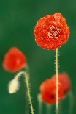

wc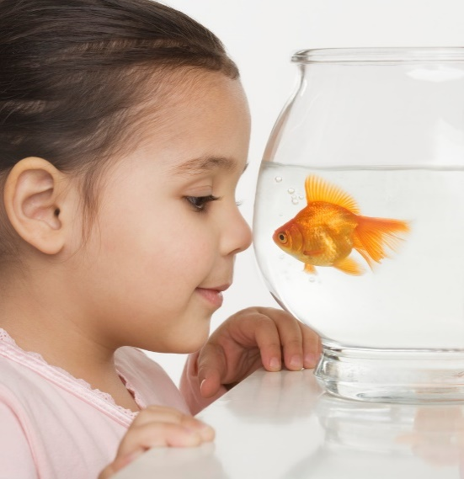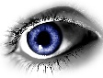zec3sokval3peć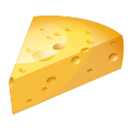lavnož3sol2vuk2osa

**______________________________**

**______________________________**

**______________________________**

**______________________________**

**______________________________**

**______________________________**

**______________________________**

**______________________________**