ODGOJNO – OBRAZOVNO PODRUČJE: IZOBRAZBA U OBAVLJANJU POSLOVA
ZADATAK: DANAS JE VAŠ ZADATAK DA PRIPREMITE SVOJU ŠKOLSKU TORBU I PERNICU KAKO BI IH UREDNE DONIJELI U ŠKOLU!

- NAJPRIJE OŠILJITE SVOJE OLOVKE I BOJICE I UREDITE SVOJU PERNICU

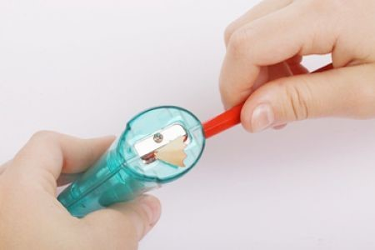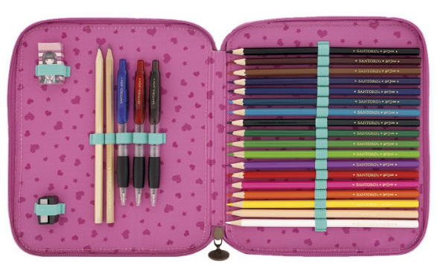

- PREGLEDAJTE I UREDITE SVOJU ŠKOLSKU TORBU

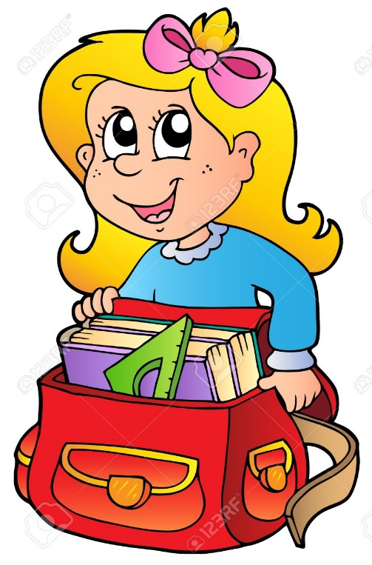

- S UREĐENOM TORBOM DOĐITE U ŠKOLU! 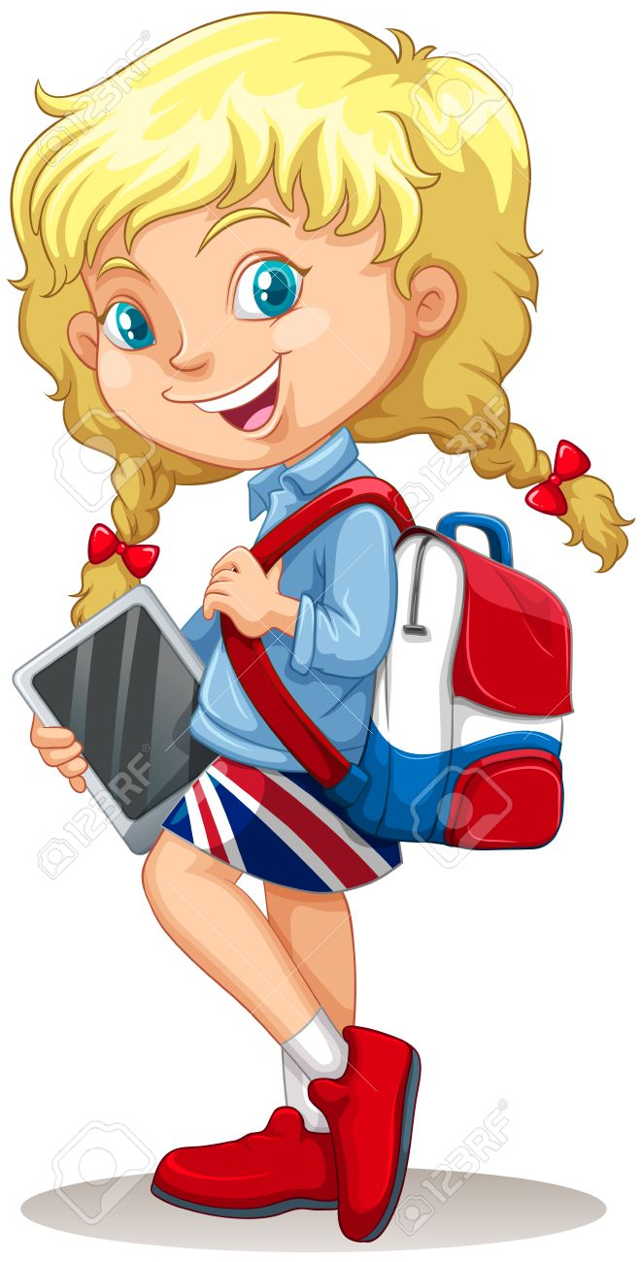 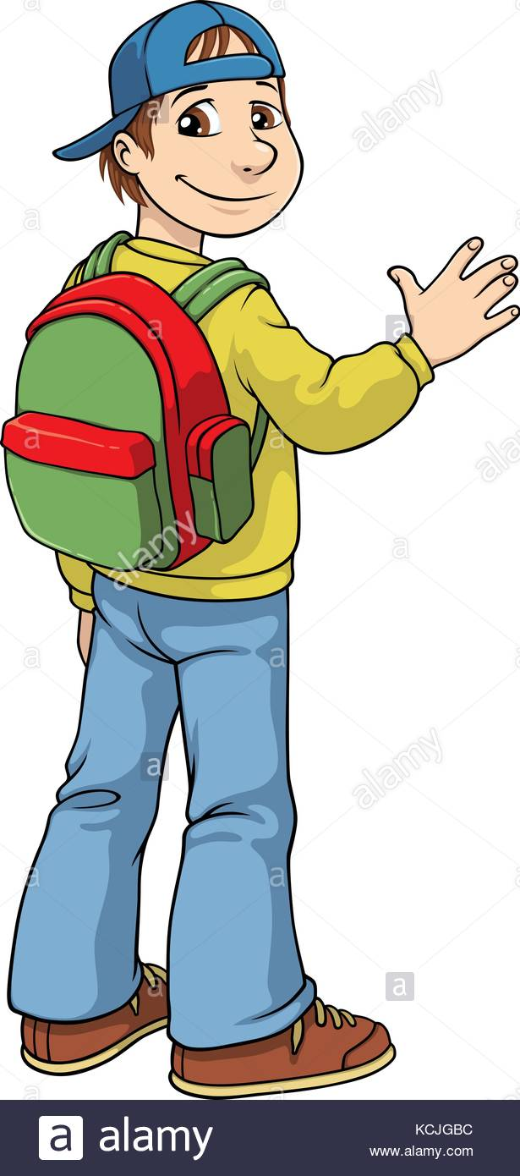

* Slike su uzete s internetskih stranica:
https://previews.123rf.com/images/lenm/lenm0907/lenm090700056/5171834-kid-packing-school-bag-with-clipping-path.jpg
https://previews.123rf.com/images/clairev/clairev1103/clairev110300059/9133396-cartoon-girl-with-school-bag.jpg
https://previews.123rf.com/images/blueringmedia/blueringmedia1511/blueringmedia151100641/48543148-little-girl-with-schoolbag-and-tablet-illustration.jpg
https://c8.alamy.com/comp/KCJGBC/vector-cartoon-of-a-school-boy-with-a-school-bag-on-his-back-and-a-KCJGBC.jpg

