ODGOJNO – OBRAZOVNO PODRUČJE: IZOBRAZBA U OBAVLJANJU POSLOVA
ZADATAK: U JESEN SE PRESAĐUJE CVIJEĆE, ČESTO MAĆUHICE.
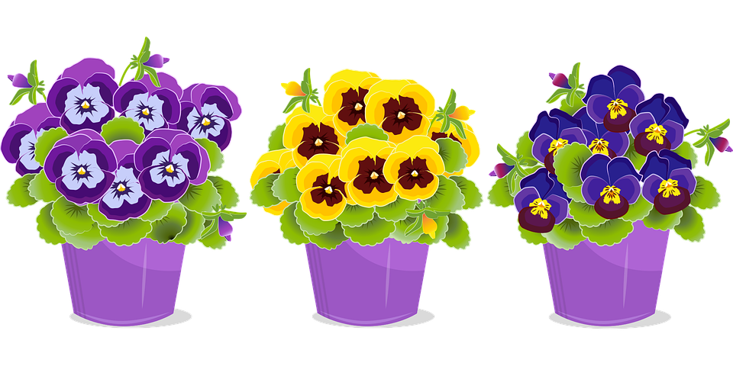

POGLEDAJTE SLIKE I POMOGNITE VAŠIM UKUĆANIMA U POSLOVIMA PRESAĐIVANJA!
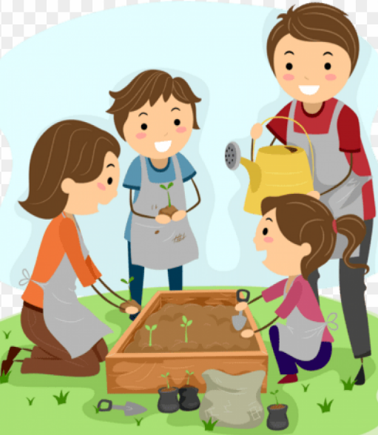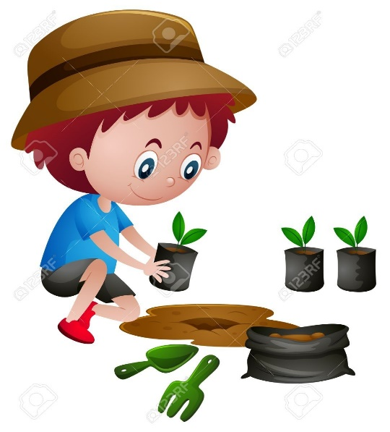

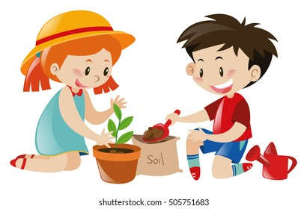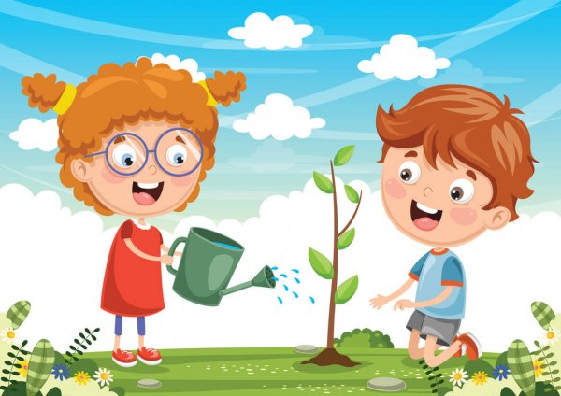

* Slike su uzete s internetskih stranica:
https://thumbs.dreamstime.com/b/pot-pansy-plant-vector-color-illustration-pot-pansy-plant-beautiful-pansy-flower-vector-color-drawing-160156628.jpg
https://toppng.com/uploads/preview/happy-happyfamgarden-twitter-kids-gardening-clipart-11563118980k5jazggrfz.png
https://i.pinimg.com/originals/23/02/63/2302639f3336bb686030b460558db173.jpg
https://image.shutterstock.com/image-vector/boy-girl-planting-tree-illustration-260nw-505751683.jpg
https://st3.depositphotos.com/1642684/18779/v/600/depositphotos_187792530-stock-illustration-vector-illustration-kids-planting.jpg

