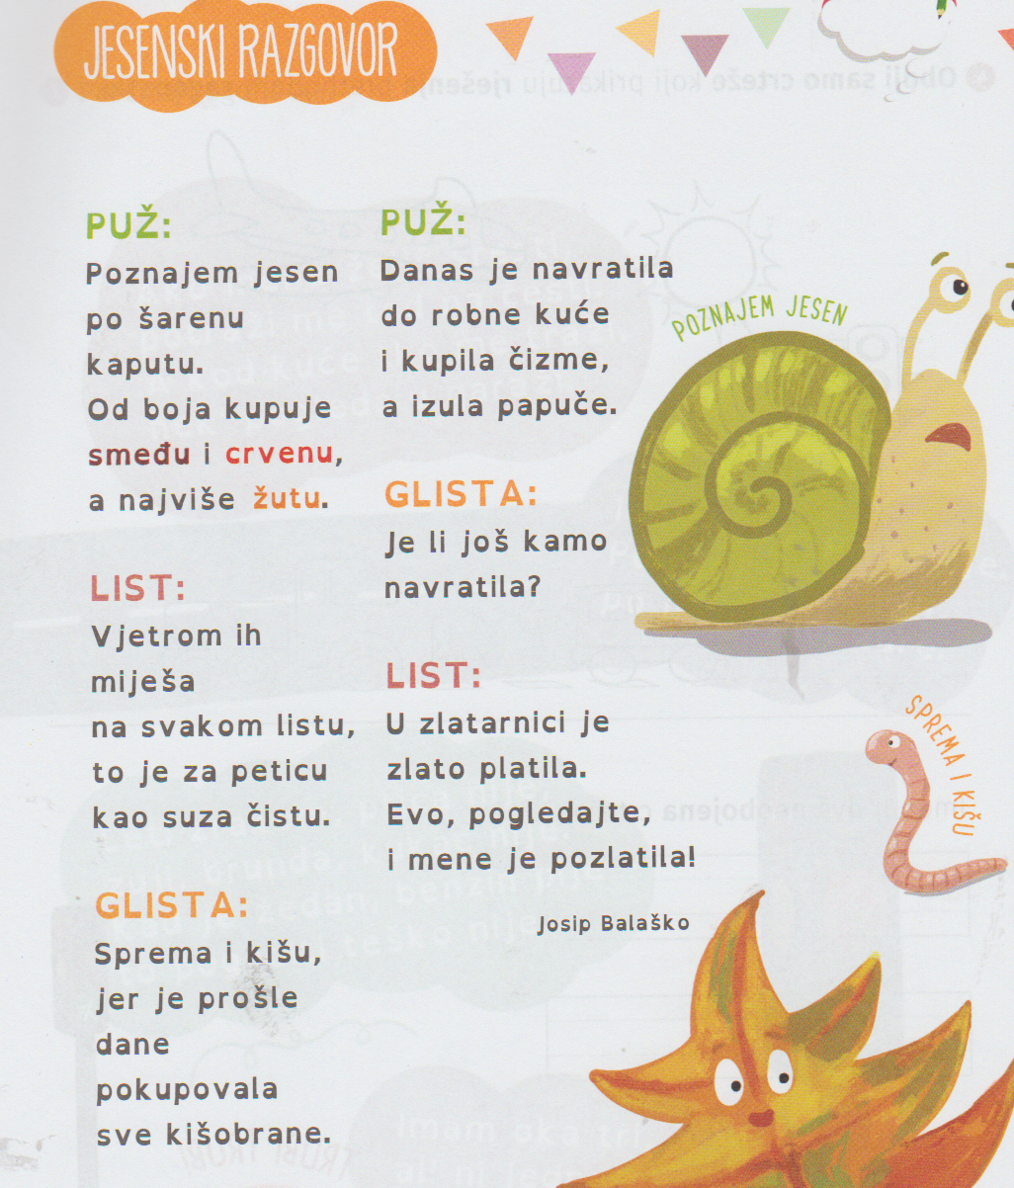

Izvor: Škrinjica slova i riječi 2, Alfa 2020.

1.Tko razgovara o jeseni?
________________________________________________________________________________________________________________

2.Po čemu puž prepiznaje jesen?
________________________________________________________________________________________________________________

3.Koju boju jesen najviše voli?
________________________________________________________________________________________________________________

4.Čime jesen miješa boje?
________________________________________________________________________________________________________________

