ODGOJNO – OBRAZOVNO PODRUČJE: SKRB O SEBI
ZADATAK: POGLEDAJTE SLIKE, RECITE ŠTO JE NA NJIMA I PROČITAJTE UPUTE PA ZAJEDNO S UKĆANIMA PRIPREMITE KOMPOT OD KRUŠAKA!
ŠTO VAM JE SVE POTREBNO:
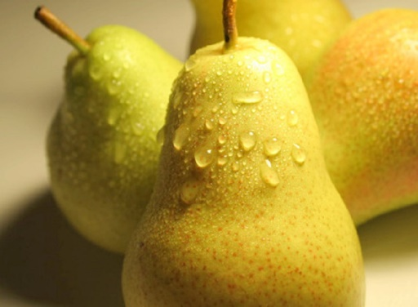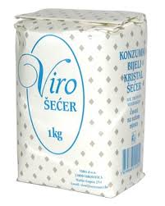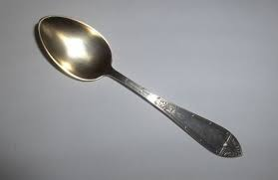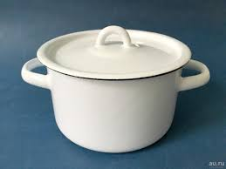

1. OPERITE KRUŠKE
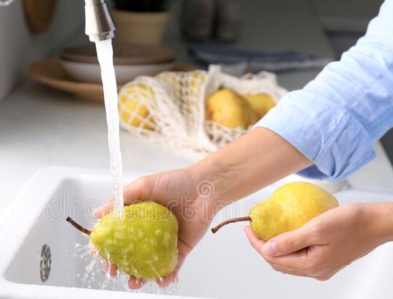

2. OČISTITE I NAREŽITE KRUŠKE NA KOMADIĆE

3. U LONAC ULIJTE VODU I STAVITE KRUŠKE
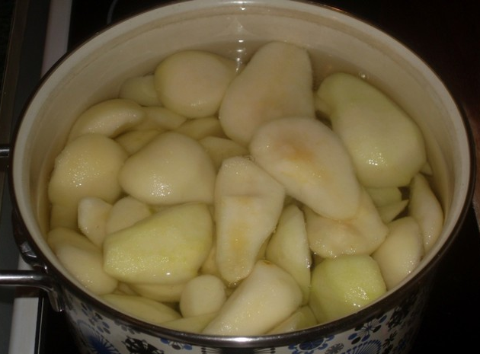
4. UZ POMOĆ ŽLICE DODAJTE ŠEĆER I CIMET PA SVE POMIJEŠAJTE I KRATKO PROKUHAJTE
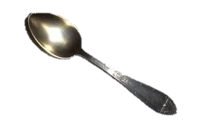
5. KUHANI KOMPOT OHLADITE I SERVIRAJTE!
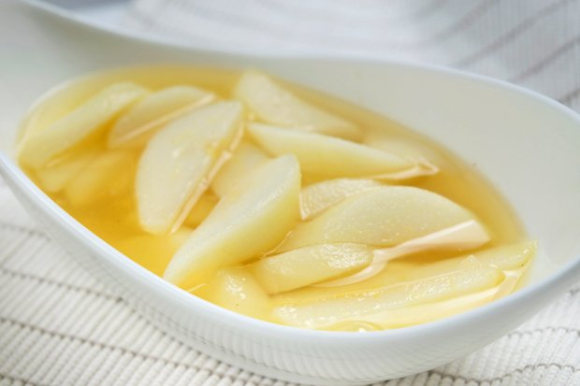
DOBAR TEK!

* Slike su uzete s internetskih stranica:
http://bosanskikuhar.ba/images/recepti/kompot%20od%20kru%C5%A1aka.jpg
https://d17zv3ray5yxvp.cloudfront.net/variants/WfJUPVJHDjks37UpuZ8bRcug/57ed05bea98bceae5f0eaada26b69cee6c61471d
https://finirecepti.net.hr/wp-content/uploads/2016/10/pranje-jabuke-825x510.jpghttps://tuzlanski.b-cdn.net/wp-content/uploads/2015/05/jabuka-600x298.jpghttps://woman365pro.com/wp-content/uploads/2019/02/%D0%A1%D0%BC%D1%83%D0%B7%D0%B8-
https://balkanlunchbox.com/wp-content/uploads/2015/11/apple-compote-stewed-apples-kompot-od-jabuka-00.jpg
https://media2.24aul.ru/imgs/578487d923bbeb544cf1cf6d/
https://www.google.com/url?sa=i&url=https%3A%2F%2Fwww.healthylittlefoodies.com%2Fbaked-pears%2F&psig=AOvVaw3PLwXEpPQN4ZyNChCkGPFV&ust=1633897935901000&source=images&cd=vfe&ved=0CAgQjRxqFwoTCID4s6WWvvMCFQAAAAAdAAAAABAI

