i kao...

igla

i kao...

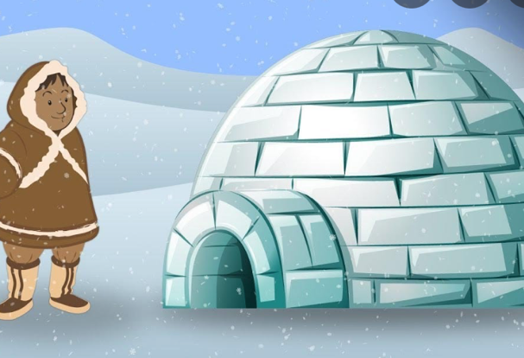

iglu