ODGOJNO – OBRAZOVNO PODRUČJE: IZOBRAZBA U OBAVLJANJU POSLOVA
1. ZADATAK: POGLEDAJTE SLIKE, A ZATIM PREGLEDAJTE CVIJEĆE U VAŠOJ KUĆI! POGLEDAJTE DA LI IMA BOLESNOG I OSUŠENOG LIŠĆA NA CVIJEĆU U VAŠOJ KUĆI!
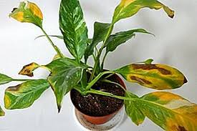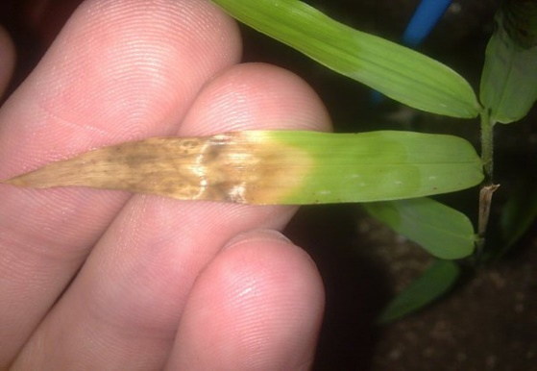
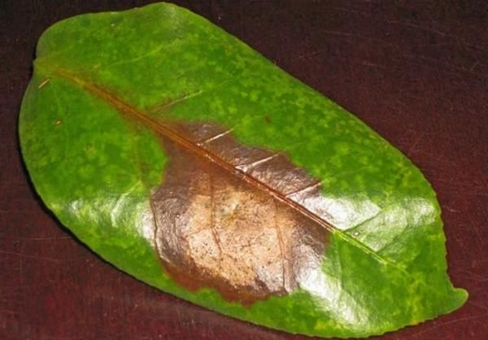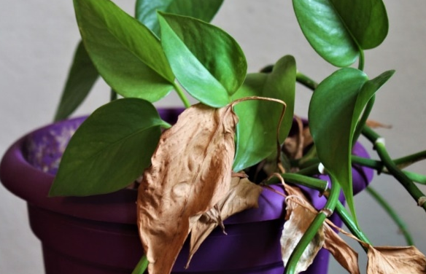
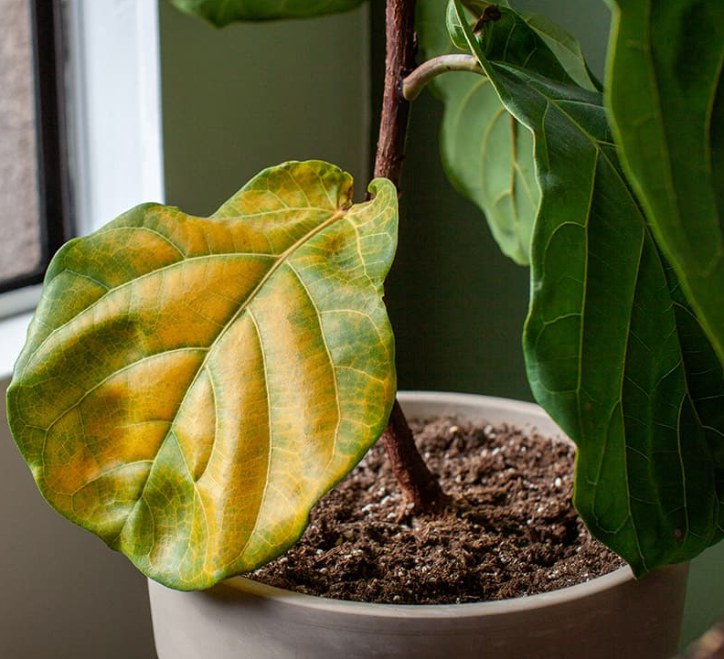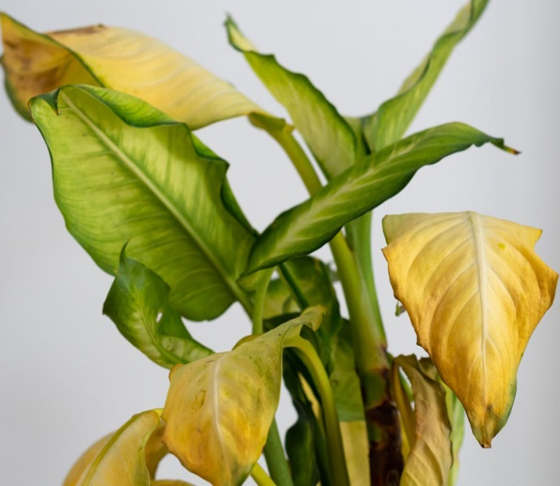

2. ZADATAK: AKO NA VAŠEM CVIJEĆU U KUĆI IMA TAKVOG OSUŠENOG I BOLESNOG LIŠĆA, POTRGAJTE ILI ODREŽITE ŠKARAMA!

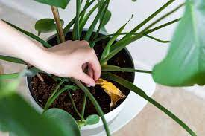

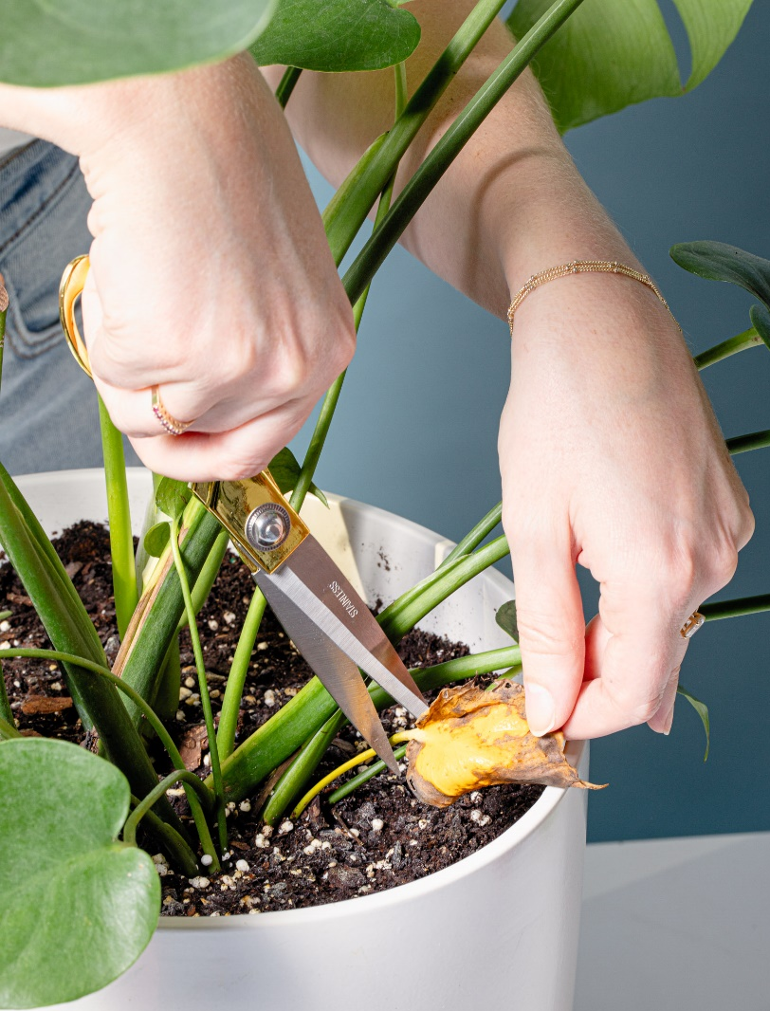

* Slike su uzete s internetskih stranica:
https://img.crushingplants.info/img/glav-2018/bolezni-diffenbahii-kak-pomoch-tropicheskoj-krasavice-2.jpg
https://encrypted-tbn0.gstatic.com/images?q=tbn:ANd9GcQ8cbD41T5W3Gg3LMHURaikdXhYBa0Dg8U2Ew&usqp=CAU
https://img.monarkinsulation.com/img/pocvet-2020/lipkie-listya-u-komnatnih-rastenij-prichini-i- borba-3.jpg
https://houseplanthelp.com/wp-content/uploads/2019/07/Cut-Off-Dying-Leaves.jpg https://morningchores.com/wp-content/uploads/2021/08/houseplant-disease.jpg
https://www.gardeningknowhow.com/wp-content/uploads/2009/07/yellow-leaves-1.jpg
https://cdn.apartmenttherapy.info/image/upload/v1602678007/at/art/photo/2020-10/How-To-Clean-Plants/How-to-Clean-Plants-4.jpg
https://encrypted-tbn0.gstatic.com/images?q=tbn:ANd9GcSHO7PDfLFT0QYqOZl8proXvU2Yxrkeuh-F99er_ycHhmrRGIpN65g8eGfFojSxNLxADjQ&usqp=CAU

