ODGOJNO – OBRAZOVNO PODRUČJE: SKRB O SEBI
ZADATAK: POGLEDAJTE SLIKE PA UZ POMOĆ VAŠIH UKUĆANA PRIPREMITE PITU S JABUKAMA!
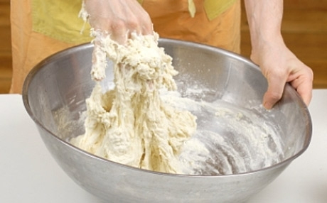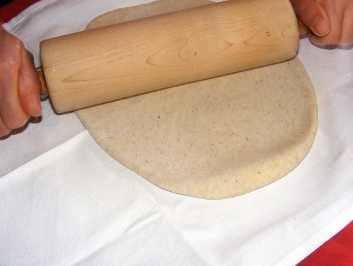

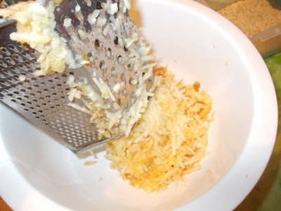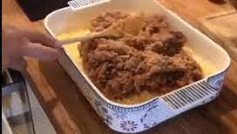

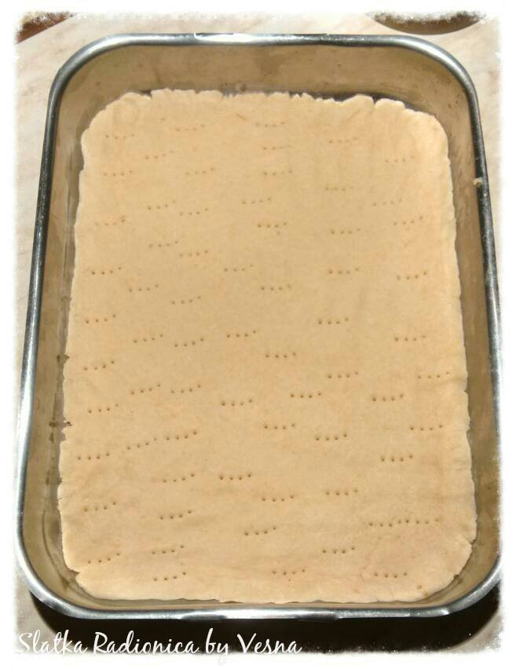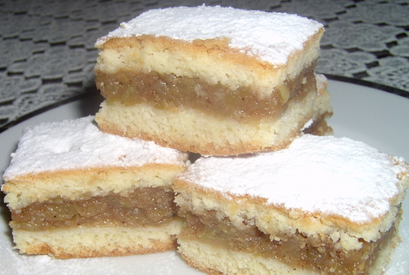

* Slike su uzete s internetskih stranica:
https://gorila.jutarnji.hr/wp-content/uploads/gorila_slike/w460/pizza_tijesto.jpg
https://lh3.googleusercontent.com/proxy/-xTlM44bJ__Xf7jy681NO3ko-ivd740Zy85_ASkOhq5gumfZsvHedf9j4-xO1zk_zv_IqlNkGlDjuI-AcHlZPEnrsHYrXvCas3uVypQL7e-jPPYhNlfIAu7HEbOSXfAa7knna2Jj9oo
https://lh3.googleusercontent.com/proxy/qGprBYEd0QxoEWlqVwlYWg1_IZzqWhhMPfuha9LPxpesO5BYF29o-kCu2mf5_Vav0kI71l37u9xURpo9MzdZwk-lptvu_h7_QqOLTK4
https://www.dnevno.hr/wp-content/uploads/2019/10/pita.jpg

