NASLOV BAJKE:____________________________
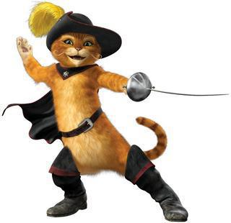
GLAVNI LIKOVI:______________________________

SPOREDNI LIKOVI:___________________________________
_________________________________________

VRIJEME RADNJE:__________________________

MJESTO RADNJE:__________________________________
_________________________________________

