ODGOJNO – OBRAZOVNO PODRUČJE: IZOBRAZBA U OBAVLJANJU POSLOVA
ZADATAK: POGLEDAJTE SLIKE PA PREGLEDAJTE SVOJE OLOVKE I BOJICE I OŠILJITE IH!
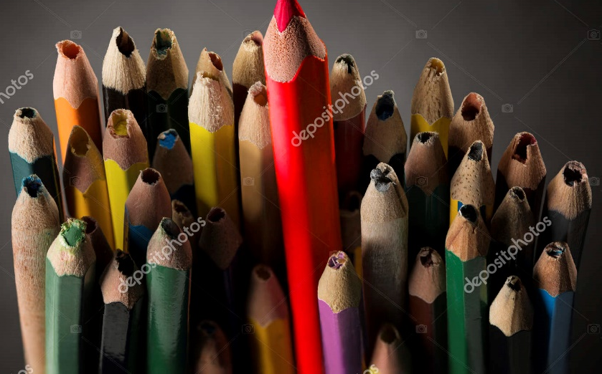
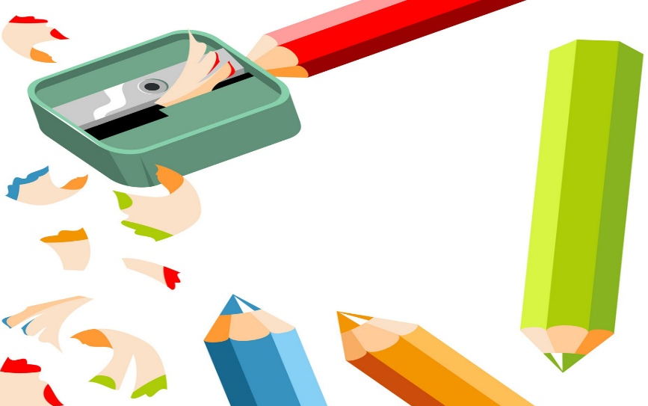
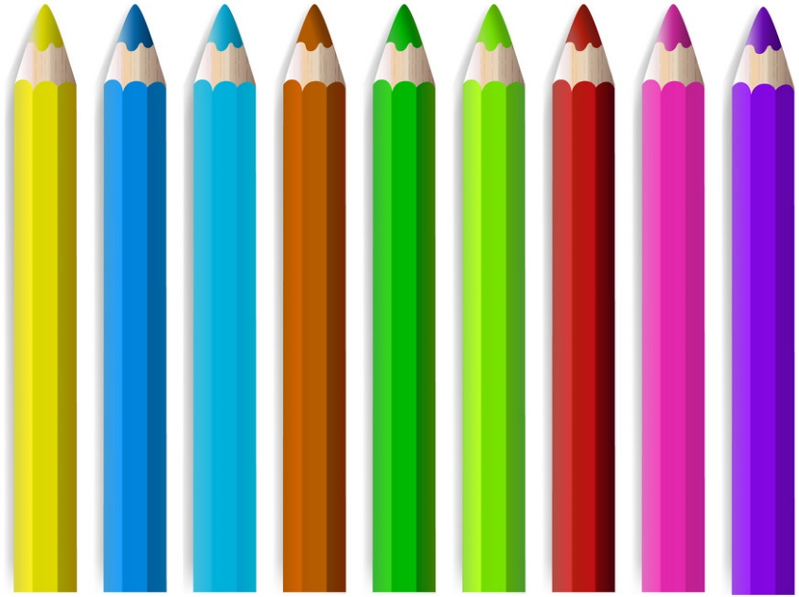

+ Slike su uzete s internetskih stranica:
https://st3.depositphotos.com/1005721/16497/i/1600/depositphotos_164973786-stock-photo-pencil-inspire-concept-sharp-creative.jpg
https://cdn4.vectorstock.com/i/1000x1000/29/88/set-of-coloured-pencils-vector-21472988.jpg
https://cdn4.vectorstock.com/i/1000x1000/46/28/pencil-sharpener-and-colored-pencils-on-white-back-vector-3254628.jpg

