Zbrajanje i oduzimanje brojeva do 10
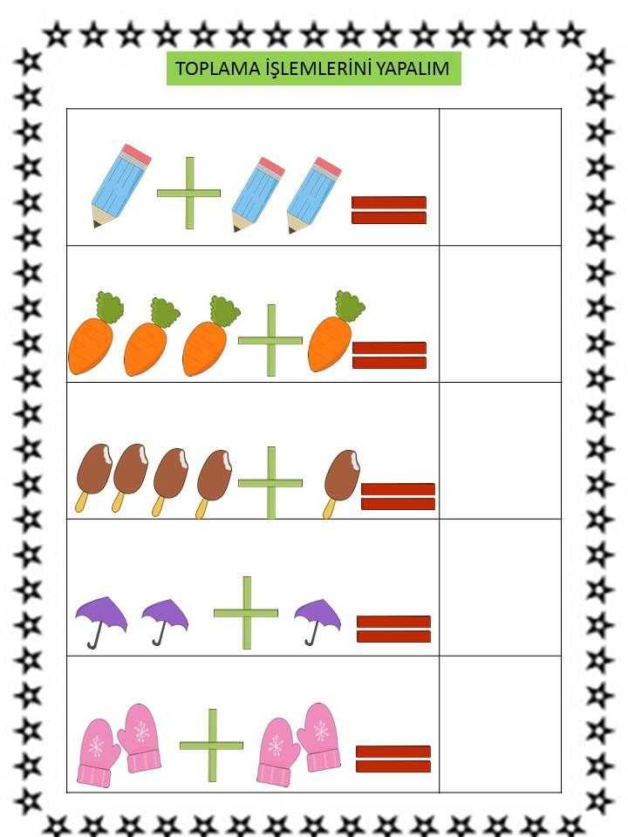
Slika preuzeta s: https://www.pinterest.com/pin/14214555065016050/

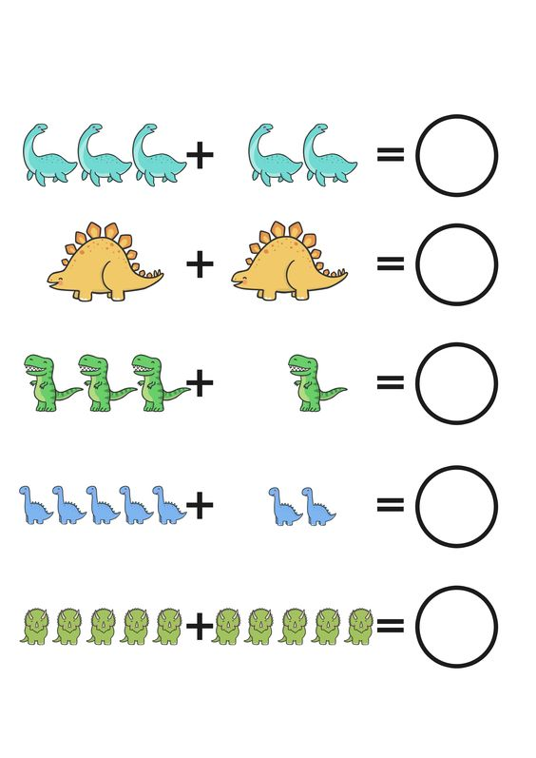
Slika preuzeta s: https://www.pinterest.com/pin/774124923514120/
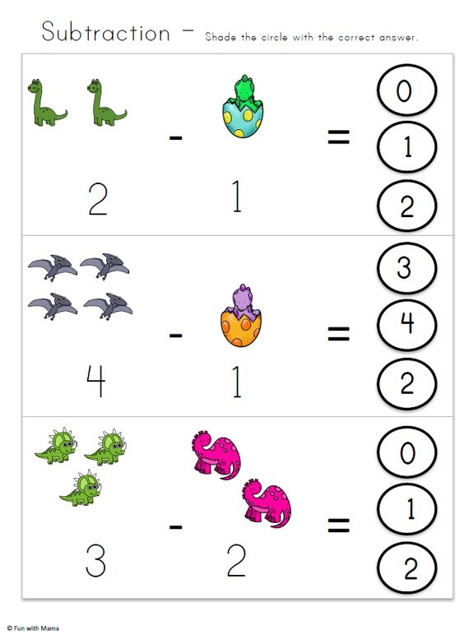
Slika preuzeta s: https://www.pinterest.com/pin/10766486599640183/

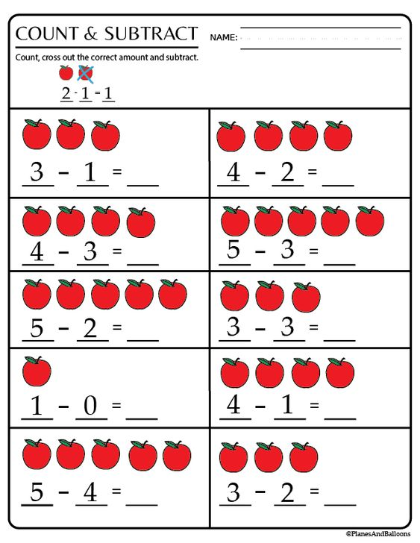
Slika preuzeta s: https://www.pinterest.com/pin/4855512086584240/

